**PRACTICAL 9: DATA SCIENCE – MONGO DB**

**Problem statement: Perform the following on some document database.**

1. **Create at least two collections**

* For Employee Database:

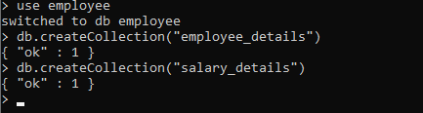

* For Student Database:



**2. Insert five records in each**

* For Employee Database:

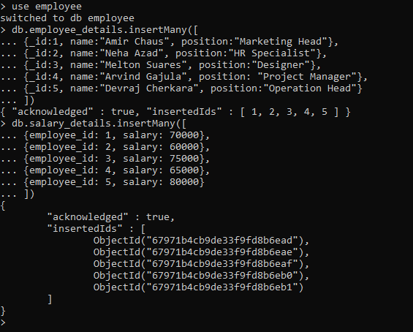

* For Student Database:



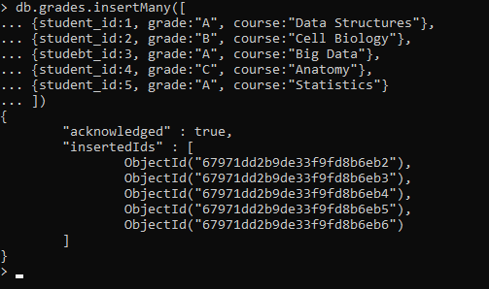

**3. Querying-filtering, join at least six queries**

* Filtering:

Query 1: Find all employees in the "Marketing" position:



Query 2: Find the employee with the highest salary:

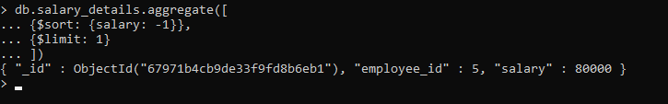

Query 3: Find all students id 2 or above:

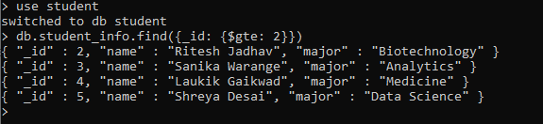

Query 4: Join employee_details and salary_details to find employee names and their salaries:

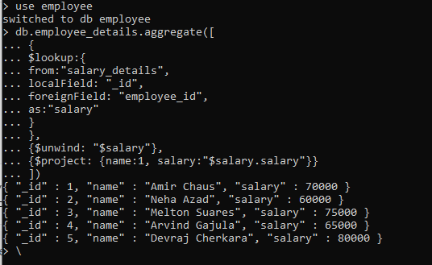

Query 5: Join student_info and grades to find student names and their courses and grades:

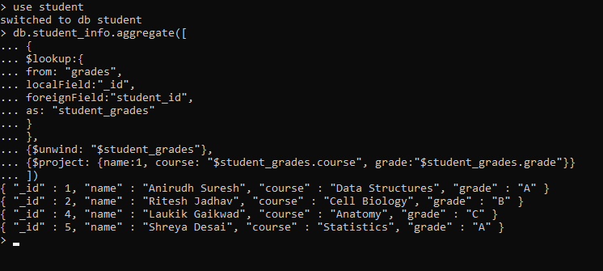

Query 6: Find all employees with the salary greater than 70,000:

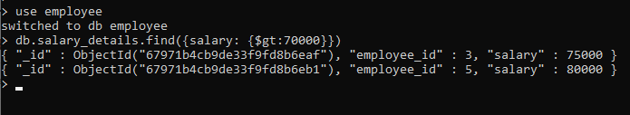

**4. Updating a record**

* Update employee’s salary (for employee with _id = 3):



* Update student’s grade (for student with student_id = 4):



**5. Deleting a record**

* Delete an employee record (for employee with _id = 4):



* Delete a student record (for student with _id = 5):

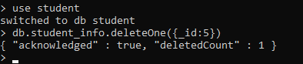

**6. Dropping collection and databases**

* Drop the salary_details collection:



* Drop the grades collection:



* Drop the student database:

